* Install GIT & make sure it is added into PATH.

1. Create a directory ‘project_dir’ & cd to ‘project_dir’.

**Output:**

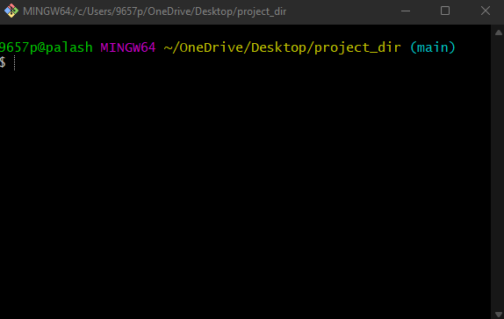

1. Initialize git version database. (git init).

**Output:** 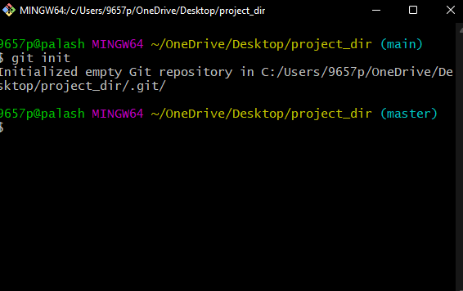

**3. Create a new file index.html.**

**Output:**

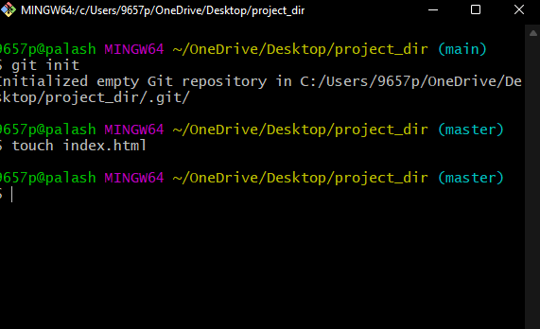

**4. Check the git status. You should find index.html as untracked file.**

**Output:**

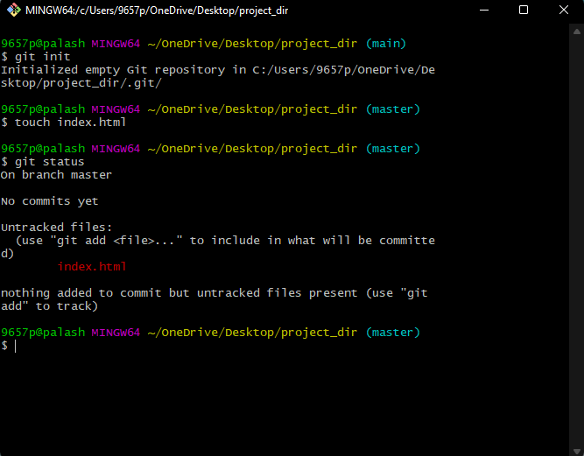

**5. Stage the index.html file.**

**Output:**

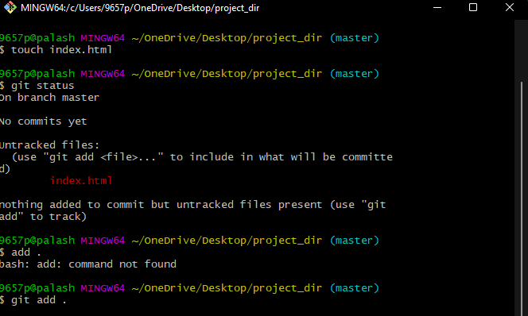

**6. Commit index.html**

**Output:**

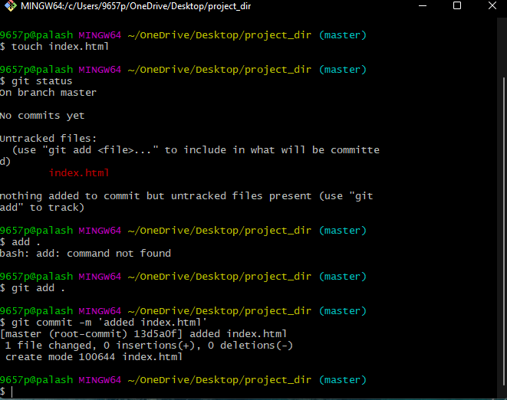

**7. Make few changes in index.html & create a new file info.txt file.**

**Changes made in index.html**

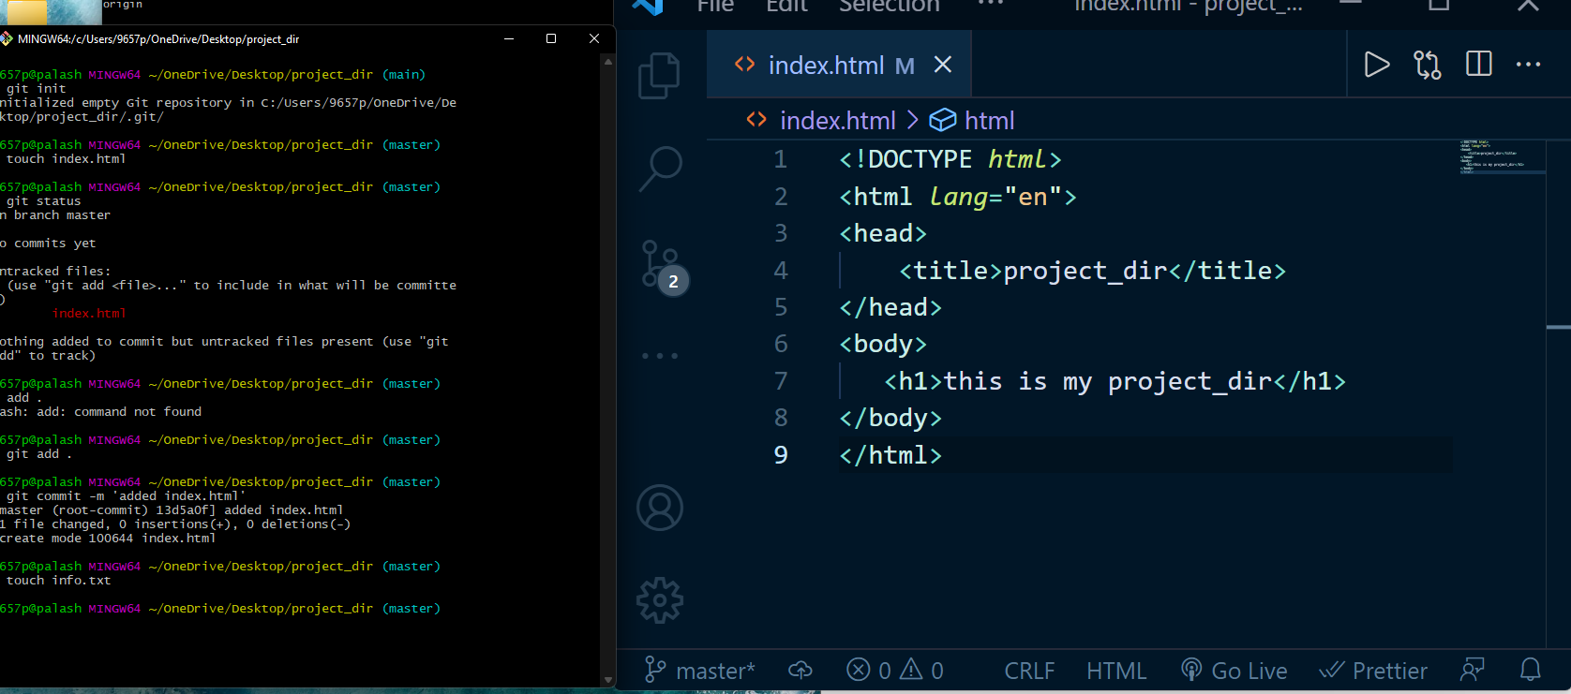

**8. Check git status. You should find index.html & info.txt as untracked files.**

**Output:**

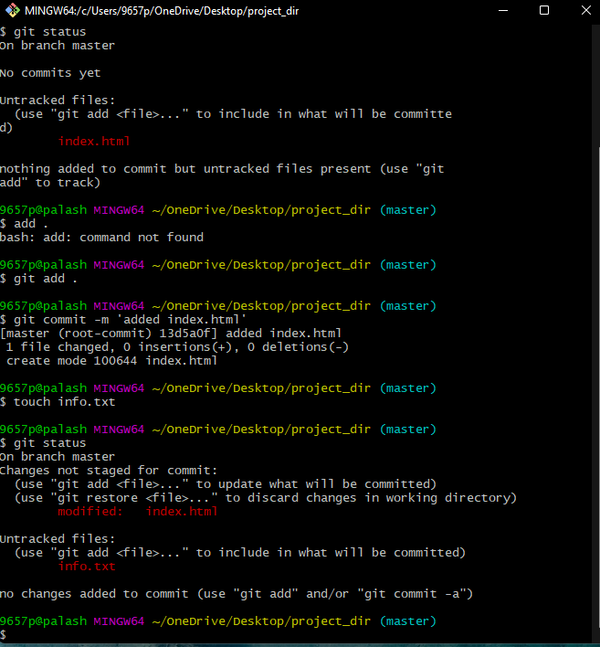

**9. Configure GIT to ignore all txt files.**

**Output:**

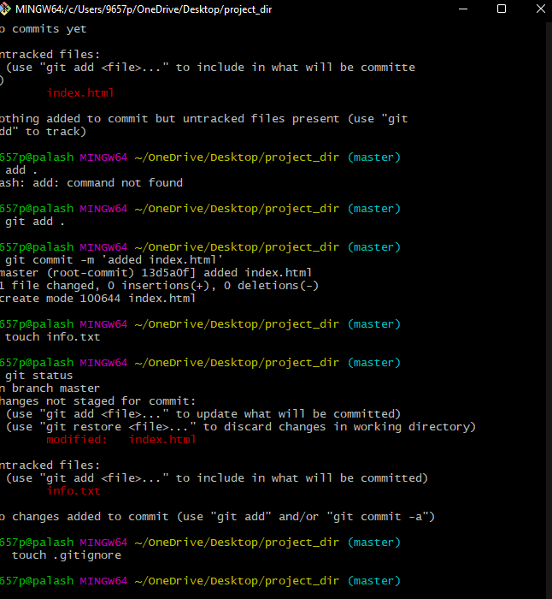

**10.** **Again check the git status. You should find only index.html as untracked file.**

**Output:**

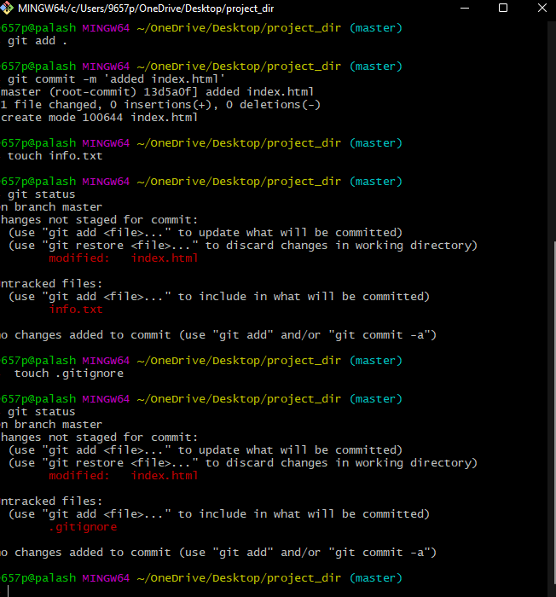

**11. Stage & commit index.html.**

**Output:**

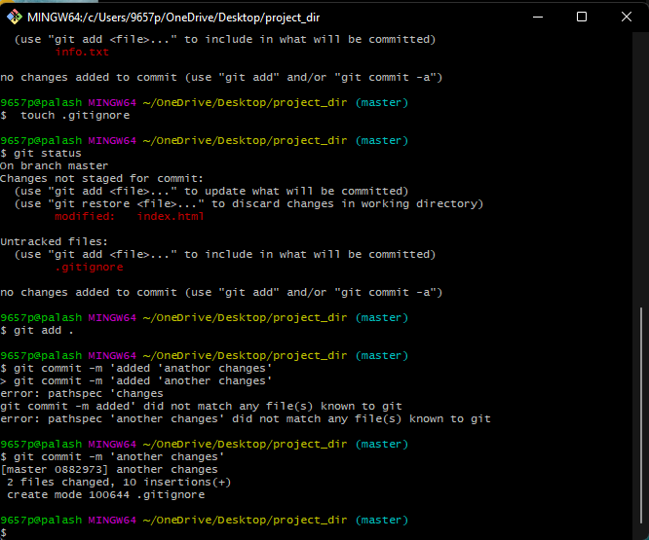

**12. Log all your comments so far.**

**Output:**

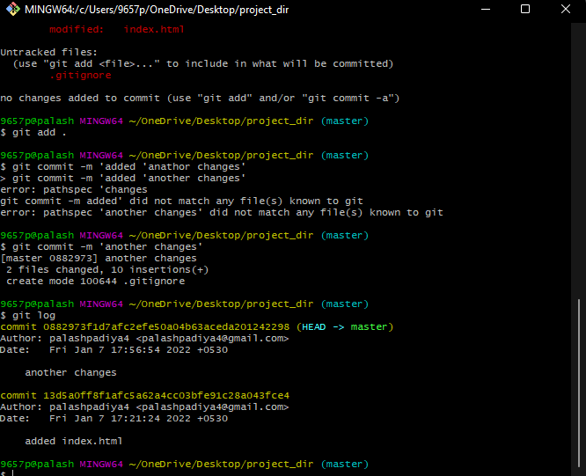

**13. Make some changes in index.html.**

**Output:**

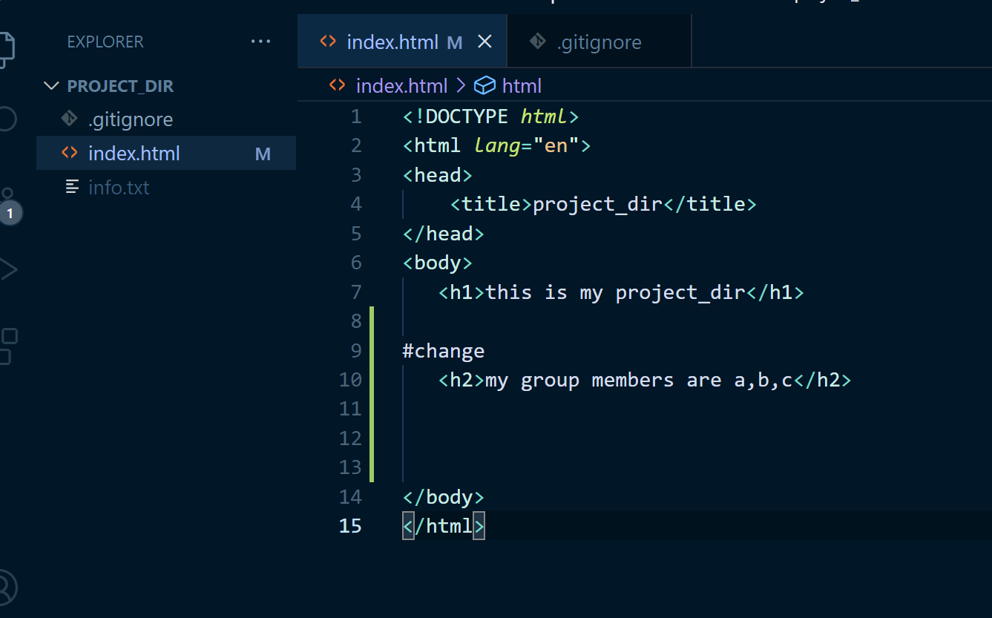

**14. Revert the change made in the previous step using git command.Output:**

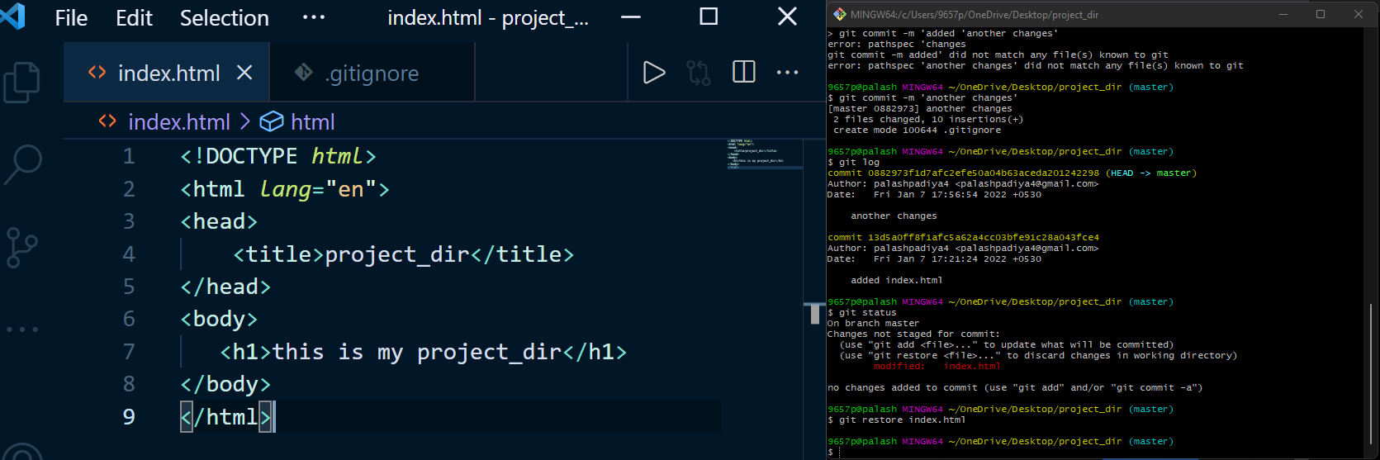

**15. Again change index.html.**

**Output:**

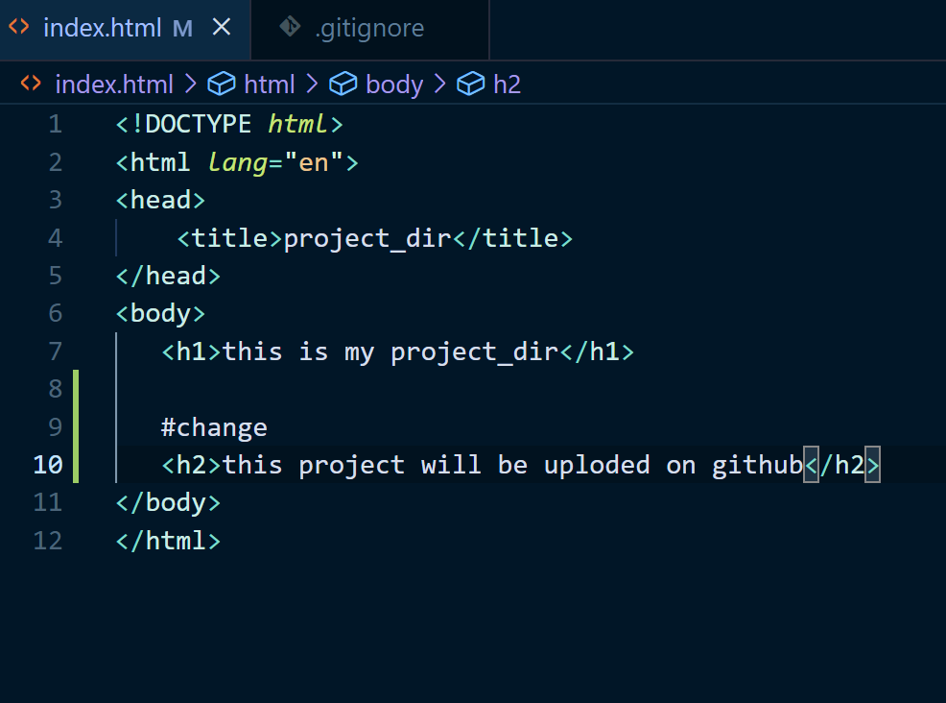

**16. Stage index.html**

**Output:**

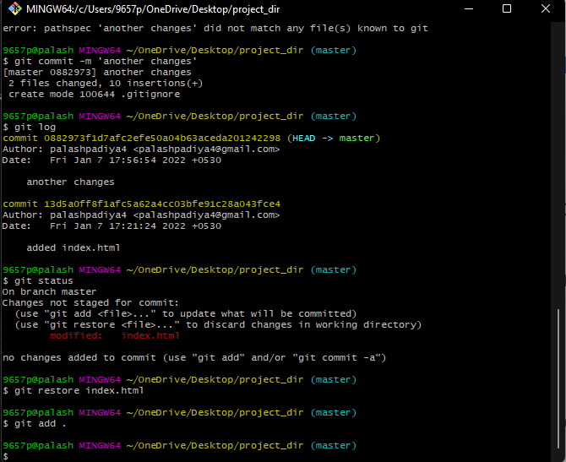

**17. Revert back the last stage.**

**Output:**

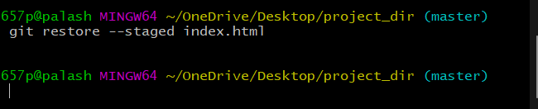

**18. Rename ‘add’ command to ‘my-add’.**

**Output:**

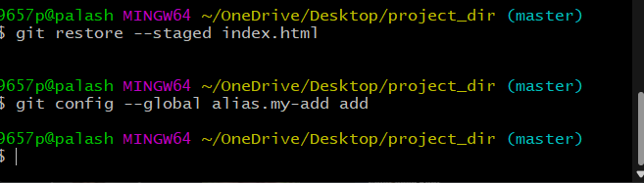

**19.** **Using my_add command Stage index.html again & commit the changes.**

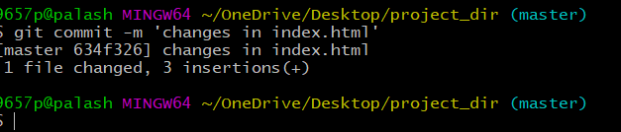

**20. Revert the last commit.**

**Output:**

